This project teaches children about the causes, events and consequences of the First and Second World Wars, the influence of new inventions on warfare, how life in Great Britain was affected and the legacy of the wars in the post-war period.
Subject Focus and Coverage
English | Persuasive posters, historical narratives, nonets.
Science | Light, Evolution and Inheritance.
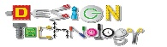  DT | Make do and mend.
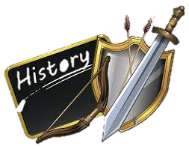  History | First World War, Second World War and Remembrance.
  Geography | Warring nations of the Second World War.
  Art | Distortion and Abstraction, Bees, Beetles and Butterflies.

