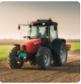This project teaches children about the features and characteristics of land use in agricultural regions across the world, including a detailed exploration of significant environmental areas. This project teaches children about the meaning and benefits of seasonal eating, including food preparation and cooking techniques
Subject Focus and Coverage
English | Non – chronological reports, diaries, leaflets, balanced arguments, presenting our farms.
  Geography | Farming in the UK, mapping using grid references, Case Study: Potato farming in Jersey, climate zones, North and South America, citrus farming in California, coffee growing in Peru, how far has your food travelled?
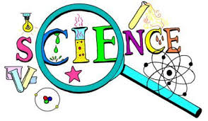  Science | Allotment habitat, animal life cycles, plant life cycles, dissection, growing, impact of modern farming.
  DT | Seasonality, benefits of seasonal eating, dicing, peeling and grating, taste test.
  Art | Still life.
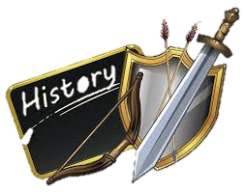  History | Dig for Victory.
  PSHE | A farmer’s year, should we import food? Debate it!

