This project teaches children about Africa past and present and the development of the slave trade. It also explores Britain’s role in the transatlantic slave trade, the causes and consequences of the European colonisation of Africa and the worldwide communities that make up the African diaspora.
Subject Focus and Coverage
English | Newspaper Reports, Persuasive Letters, Non-chronological reports, Acrostic Poems.
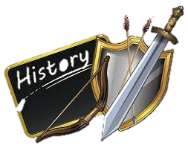  History | Growth and development of the transatlantic slave trade, Abolition and beyond, Black lives in Britain, Reflection.
  Geography | Exploring Africa today.
  Art | Trailblazers – Barrier Breakers
  PSHE | Black lives in Britain, Reflection.

