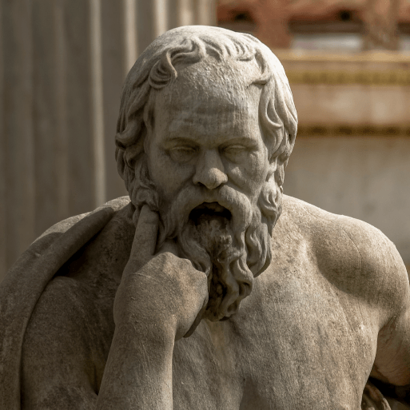
This project teaches children about developments and changes over six periods of ancient Greek history, focusing on the city state of Athens in the Classical age, and exploring the lasting legacy of ancient Greece.
Subject Focus and Coverage
English | Greek myths, balanced arguments, playscripts and odes.
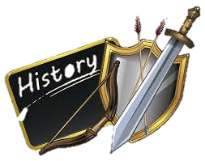  History | Time teams, sources of evidence, minoan civilisation, comparing the minoans and mycenaeans, Dark age and Archaic period, City states, democracy in Athens, roles of men and women in Athens, social hierarchy in Athens, significant Athenians, the Acropolis, Hippocrates, finding out about philiosophy, masters of mathematics, ancient and modern Olympic Games, Greek arts and culture, Alexander the Great, The Greco – Roman world, Thank you and influence of the ancient Greeks in our local area.
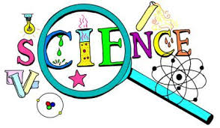  Science | Properties and Changes of Materials
  DT | Architecture
  Art | Mixed Media and Expression
  Geography | Geography of Greece

