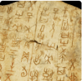This project teaches children about the history of ancient China, focusing primarily on the Shang Dynasty, and explores the lasting legacy of the first five Chinese dynasties, some of which can still be seen in the world today
Subject Focus and Coverage
English | Narratives poems, biographies and stories from other cultures.
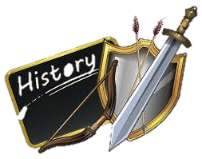  History | Dig at Yinxu, Oracle Bones, Religion in the Shang Dynasty, Significance of bronze, Jade and silk, Power and hierarchy, Everyday life in the Shang Dynasty, Warfare enquiry, Fu Hao, End of the Shang Dynasty, bronze ages around the world, Legacy of ancient China and Telling others about ancient China.
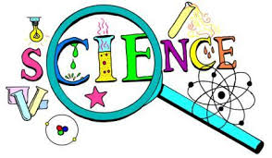  Science | Forces and Mechanisms, Earth and Space.
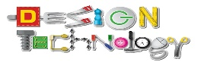  DT | Moving mechanisms.
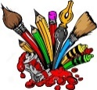  Art | Tints, tone and shades, Toatie.
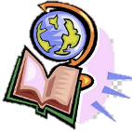  Geography | Investigating our world

